Course Methods Year 12 test two 2022

Student name: ________________ Teacher name: ________________

Task type: Response

Time allowed for this task: _____40______ mins

Number of questions: ____7_______

Materials required: Upto 3 calculators/classpads allowed

Standard items: Pens (blue/black preferred), pencils (including coloured), sharpener, correction fluid/tape, eraser, ruler, highlighters

Special items: Drawing instruments, templates, one page of A4 notes doublesided

Marks available: ___40___ marks

Task weighting: _10___%

Formula sheet provided: Yes

Note: All part questions worth more than 2 marks require working to obtain full marks.

Q1 (2 & 2 = 4 marks) (3.2.1)
Let ,
- Determine an expression for the rate of change of .

- Determine given that .

Q2 (3 marks) (3.2.3-3.2.9)
Determine in terms of given that and when .

Q3 (4 marks) (3.2.21-3.2.22)
A particle travels along a straight line such that its acceleration at time seconds is equal to . When the displacement is 10 metres and when the displacement is 20 metres. Determine the displacement when .

Q4 (6 marks) (3.2.19-3.2.20)
Make a sketch showing the graphs of and indicating clearly on your sketch the coordinates (2 dp) of any stationary points, inflection (if any) and of any points where the functions intersect each other.
Determine the area between the graphs to 2 dp.

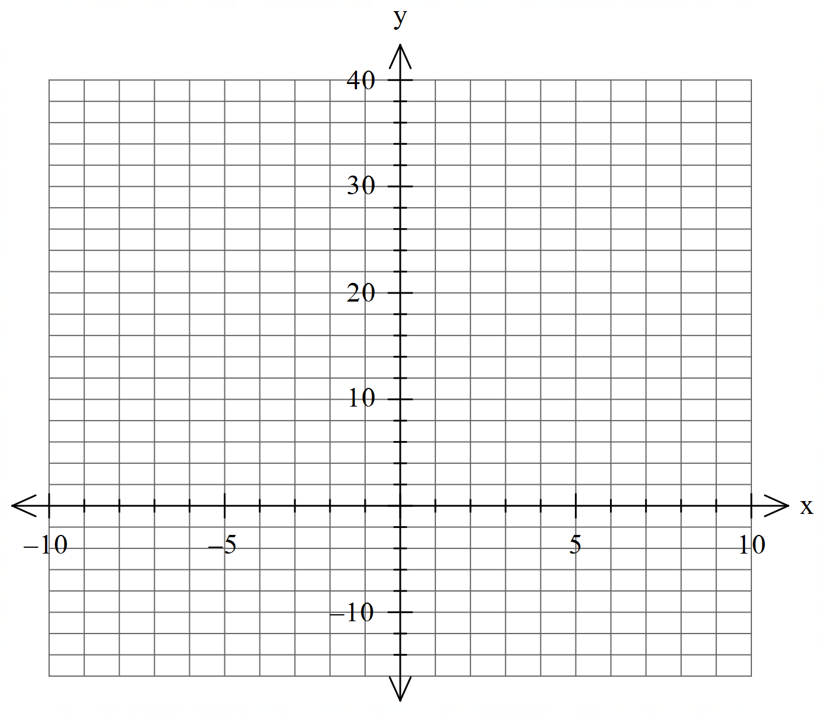

Q5 (4 & 3 = 7 marks) (3.1.2-3.1.3)
Let
- Using calculus determine all stationary points and their nature. Justify.

- Determine the x values of any inflection points.

Q6 (2, 2, 2 & 2 = 8 marks) (3.2.15-3.2.17)
Consider the function which is graphed below.
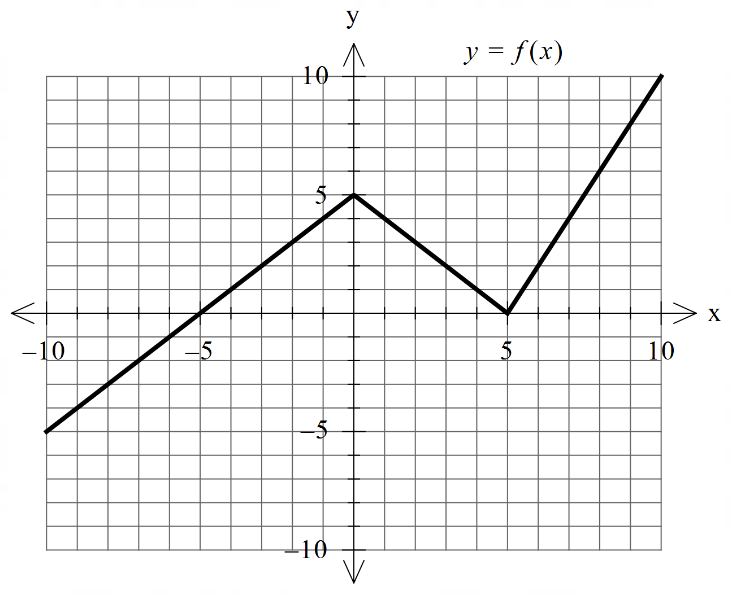

Determine the following.
- .

- .

- when .

- The area enclosed between and the line .

Q7 (1, 3 & 4 = 8 marks) (3.2.5-3.1.6)
The cross section of a mountain can be given by for metres where = height at metres.
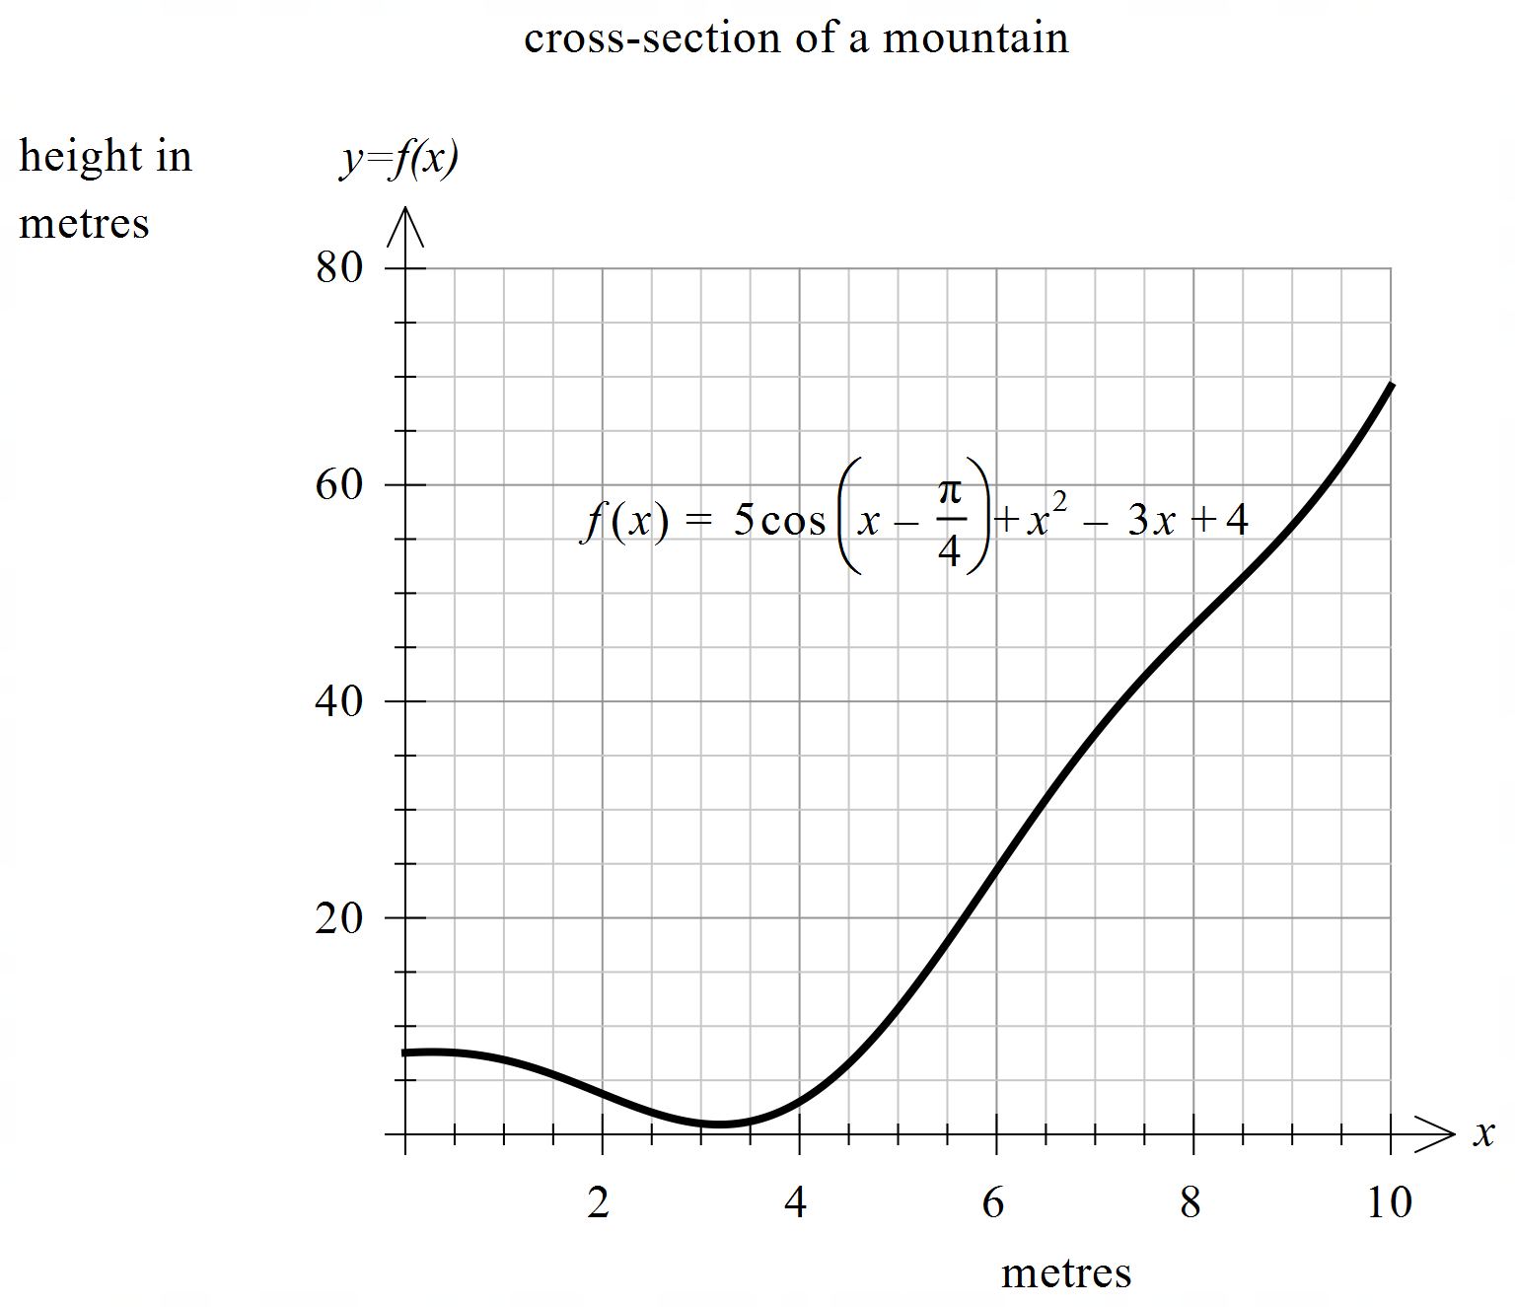

- Determine .

- Determine the minimum height of the mountain to 2 decimal places. Justify.

Q7 continued

- A water collection tank will be placed at the steepest part of the mountain. Determine the coordinates of this point to 2 decimal places. Justify.

Extra working space

